**LAMPIRAN OUTPUT**

**Halaman Home**

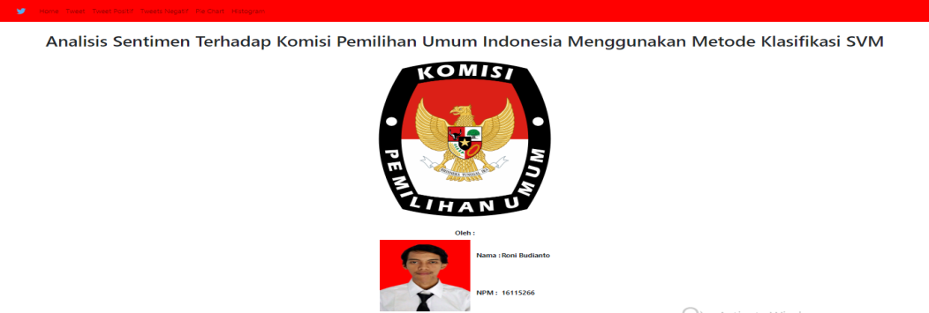

**Halaman Tweet**

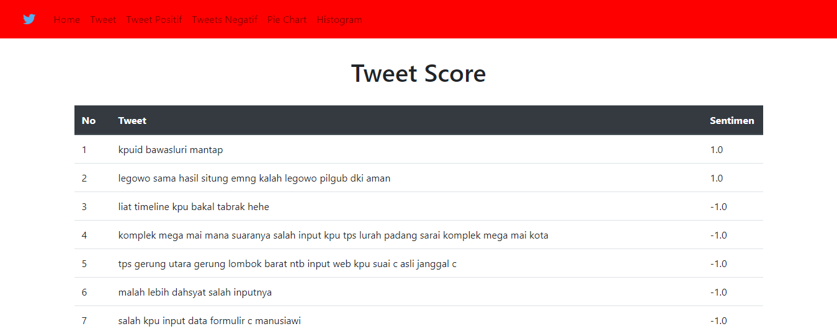

**Halaman Tweet Positif**

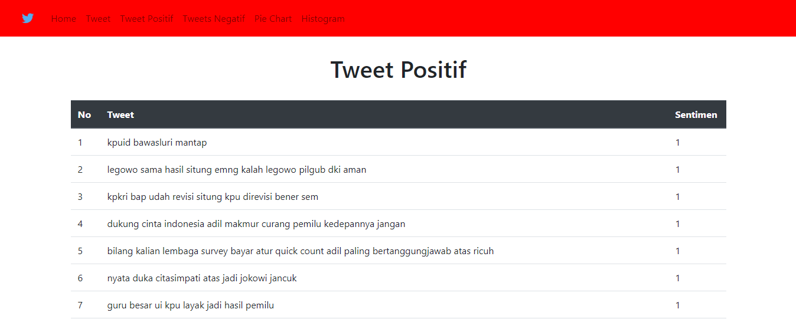

**Halaman Tweet Negatif**

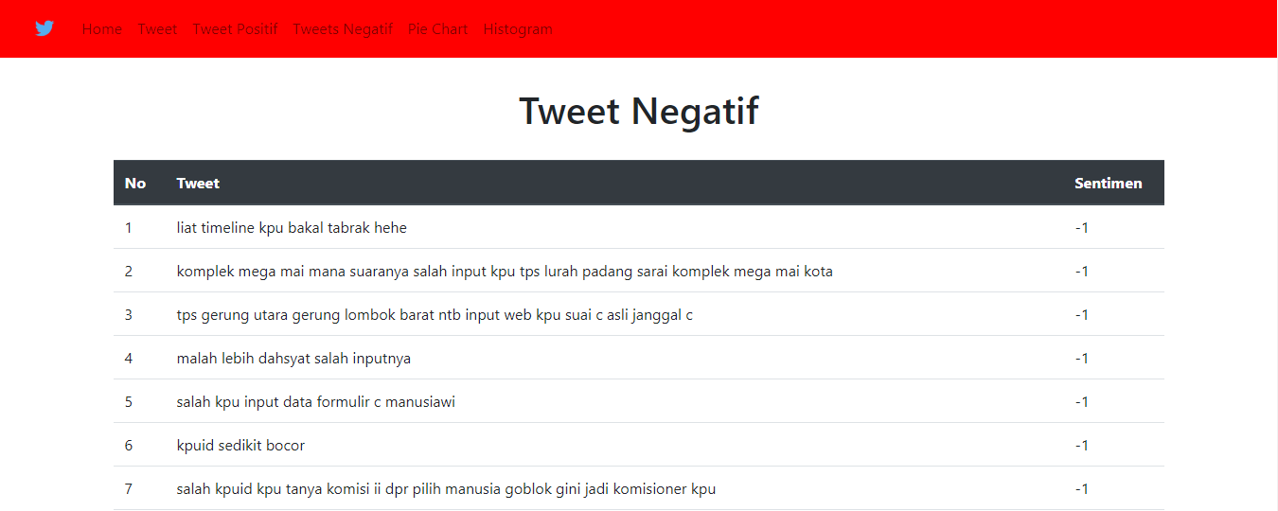

**Halaman Diagram Pie**

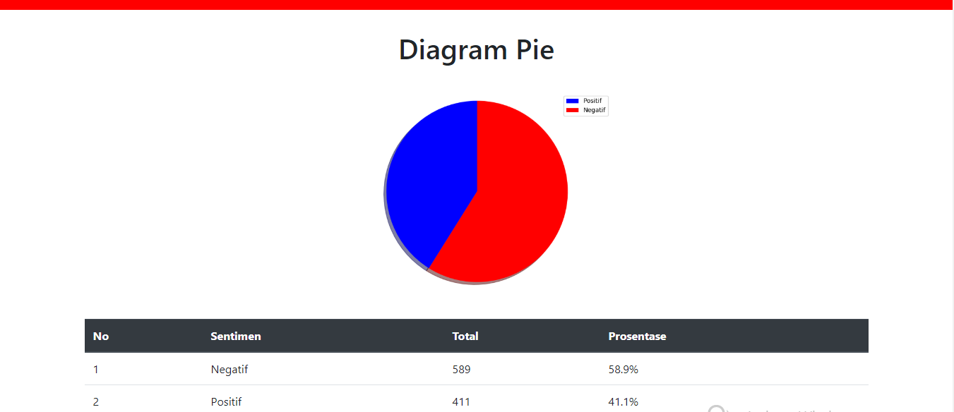

**Halaman Histogram**

